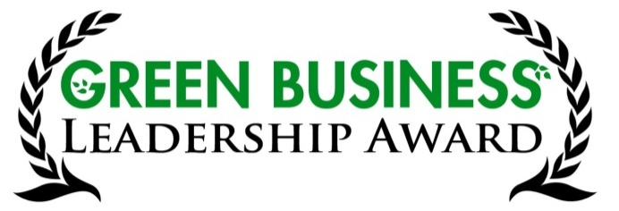
Nomination for Green Business Leadership Award 2015
Sponsored by the Green Business Roundtable

Nomination Criteria:
For-Profit Business that demonstrates leadership, risk, and innovation in utilizing environmentally responsible, healthy & profitable business practices in the areas of:
- Energy & Water - efficiency & conservation measures
- Transportation - options & alternatives to single occupant vehicles, reduction in reliance on fossil fuel vehicles
- Pollution & Waste - “reduce, reuse & recycle” practices
- Manufacturing & Purchasing - sustainable process & local focus
- Other Contributions to the Community - e.g., environmental preservation, civic goodwill & education

Please complete this form and send it to mreott@earthly-ideas.com or Michelle Reott, 250 W. 16th St, Durango, CO 81301 no later than November 20, 2015.
Your name:
Phone:
Email:
Nominee’s Business name:
Nominee’s owner/manager name:
Phone:
Email:
See criteria above and check appropriate categories. Please explain how this business specifically contributes in each of those areas. We welcome supporting company and media information to make a robust, detailed nomination so attach additional pages as needed. I am nominating this business because:

