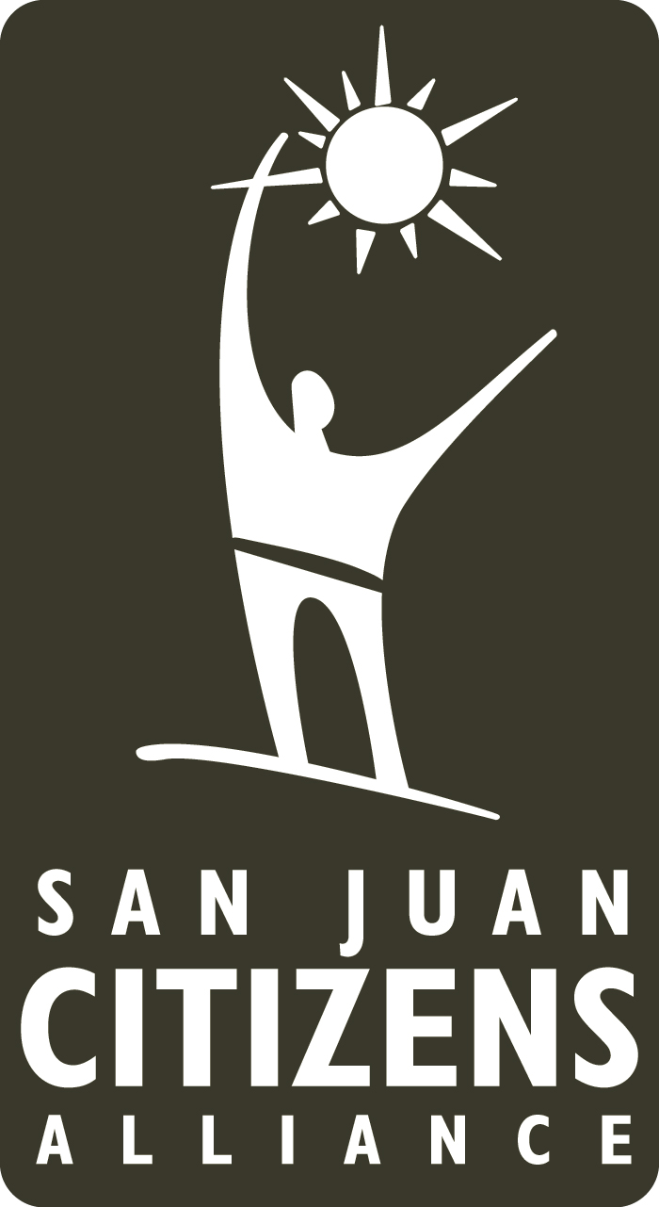
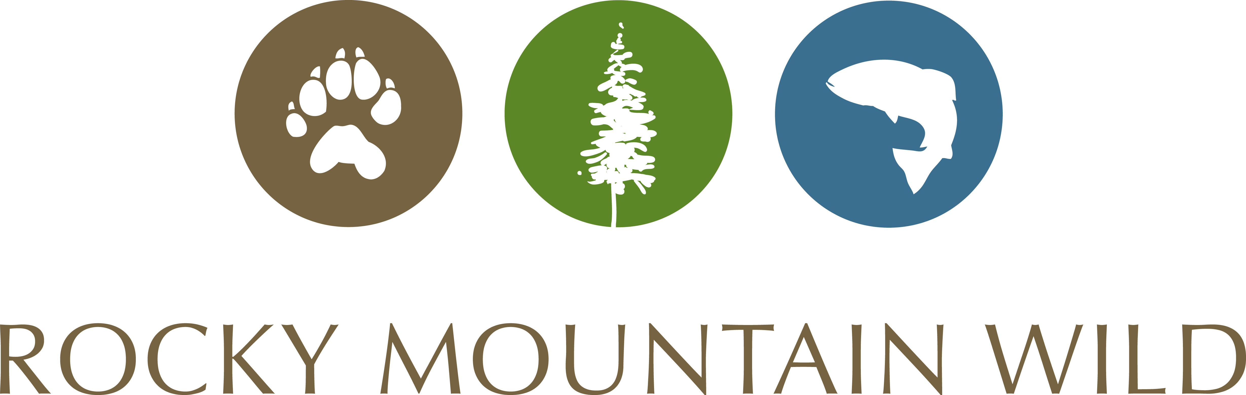

Banff Mountain Film Festival World Tour
2018 Sponsorship Opportunities

Peak Sponsor - $1500
- Only one company accepted at the Peak Sponsor level. First come, first served
- 10 complimentary tickets
- Banner displayed in most prominent location
- Largest logo prominently placed on posters
- Prominent full page ad space on the back page of the program
- Logo most prominently displayed on both organizations websites and emails with link
- Acknowledgement of headline sponsorship to attendees at intermission
- Opportunity to table at the event
- Shout outs on social media by both SJCA & Rocky Mountain Wild (FB = 5500+, Twitter = 4500+)

Base Camp Sponsor - $1000
- Up to 10 complimentary tickets*
- Logo prominently placed on the posters and program
- Logo prominently displayed on both organizations websites and emails with link
- Acknowledgement of sponsorship to attendees at intermission
- Opportunity to table at the event
- Opportunity to display banner at event
- Shout outs on social media by SJCA and Rocky Mountain Wild (FB = 5500+, Twitter = 4500+)
Trailhead Sponsor $500
- Up to 5 complimentary tickets*
- Logo displayed on the posters and program
- Logo displayed on both organizations websites and emails with link
- Acknowledgement of sponsorship to attendees at intermission
- Opportunity to display banner at event
- Shout outs on social media by SJCA and Rocky Mountain Wild (FB = 5500+, Twitter = 4500+)
*Number of tickets dependent on cash contribution
Contact Erika at erika@sanjuancitizens.org or (970) 259-3583 ext.3 to secure your sponsorship.
For program acknowledgement, sponsorship must be finalized by February 23rd.

Note: The receipt of any sponsorship benefit in cash or in kind, derived from any source, does not imply product or program endorsement. Additionally, receipt of such benefits will not affect our mission, goals and programmatic objectives.

