TO: Interested Parties

FROM: Lori Weigel / New Bridge Strategy
Bob Meadow / Lake Research Partners

DATE: March 12, 2019

RE: Strong Support for Restoring Wolves to Colorado Evident in New Survey

The bipartisan research team of Lake Research Partners and New Bridge Strategy recently completed a survey of voters throughout Colorado to assess their views of wolf restoration. The statewide study found that two-thirds of likely voters say they favor restoring wolves in Western Colorado, while only 15 percent oppose it. Support for wolf restoration is broad-based and widespread, with majority support extending across party lines, regions of the state, and all demographic groups. This support is grounded in the fact that voters say a “vibrant wolf population would be an asset to Colorado” (69 percent agree) and feel they “were an essential part of the wild habitat” so “we should encourage an increase in their numbers in the region” (72 percent). The issue is a political winner for state legislators; nearly four times more voters say they would be more likely (rather than less likely) to vote for a State Legislator who either allows restoration of wolves or votes to place such a proposal on the ballot for voters to decide this issue.

The specific key findings include:

- Two-thirds of Colorado voters favor “restoring wolves in Western Colorado.” Fully 67 percent indicate favor wolf restoration, with nearly two-in-five (39 percent) strongly favoring wolf restoration. Just 15 percent oppose the idea (only 8 percent strongly) and 18 percent say they have no opinion. This is a modest increase in support from a 2014 telephone survey in which Colorado voters were asked the same question, at which time 64 percent favored wolf restoration while 22 percent opposed the idea.

- Support is broad based and widespread. Support is strong, and with only moderate variation throughout the state and with all key demographic sub-groups including:

  - 66% of men and 68% of women;
  - 65% of voters under age 30, 71% of 30-39 year olds, 77% of 40-49 year olds and and 63% of those ages 50 and older;
  - 61% on the Western Slope, 65% on the Eastern Plains, 65% of those in Denver, 68% in the suburban Denver metro area, 68% in the Colorado Springs/Pueblo area, and 75% in Northern Colorado;
  - 77% of Latino voters, and 67% of white voters;
  - 80% of Democrats, 57% of Republicans and 65% of unaffiliated voters;
  - 64% of those from household which derive their income from ranching and farming; and
  - 68% of voters in households with hunters.

- This conceptual support extends to voting Yes on specific proposals. Respondents were asked one of three various iterations of ballot language, but in all cases, the vast majority indicated that if the election were being held today they would vote Yes in favor of a wolf restoration proposal. In fact, the Yes vote stood at a stunning 78 percent for the following ballot proposal:

“Shall there be an amendment to Colorado Revised statutes concerning the restoration of the grey wolf to Colorado, and connection therewith, requiring the Colorado Parks and Wildlife Commission to hold statewide hearings and then develop a science-based plan to reintroduce grey wolves on public lands west of the continental divide, and requiring the Commission to take steps necessary to reintroduce the grey wolf to Colorado by December 31, 2023.”

Most impressively, nearly half of Colorado voters (47 percent) say they would “definitely” vote yes in favor of this proposal. Just 15 percent reject the proposal, with only 7 percent “definitely” No. Support for this ballot language is overwhelming among all sub-groups including those from households engaged in ranching and farming (68 percent Yes, 54 percent definite Yes), Western Slope voters (68 percent Yes, 34 percent definite Yes), and households with hunters (74 percent Yes, 49 percent definite Yes). It is also solid and intense across party lines, from Republicans (68 percent Yes, 42 percent definite Yes), unaffiliated voters (76 percent Yes, 43 percent definite Yes), and Democrats (88 percent Yes, 54 percent definite Yes).

In another version of the ballot question, with the addition of requirement for compensation for injury to livestock caused by wolf restoration, overall support was nearly as high (75 percent Yes), with particularly high support in the Western Slope region (84 percent Yes).

- Colorado voters are nearly four times more likely to say they would vote for their State Senator or Representative if he or she backs wolf restoration or places such a proposal on the ballot than to say they would be vote against that Legislator because of this. No matter how the question was framed, the reaction is the same: voters are positive or at least benign in their reaction to the Legislator taking such a position, with very few saying they would be more likely to vote against their Legislator based on this, as the following graph depicts:

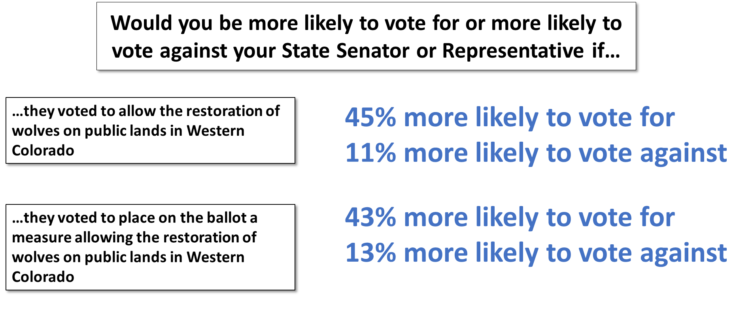

Even in the area where wolves would be restored, - the Western Slope - residents are far more likely to have a positive reaction to placing such a measure on the ballot (44% more likely to vote for Legislator, compared to 12% more likely to vote against) or simply voting to allow wolf restoration (35% more likely to vote for Legislator, compared to 18% more likely to vote against). In addition, a majority of voters across the political spectrum indicate that they would be more likely to vote for – rather than against – a Legislator who takes either position.

- These reactions to wolf restoration in Colorado among the electorate are grounded in consistent views that wolves are an asset for Colorado and play an important ecological role. There is clear agreement that restoring wolves is key to the balance of nature and for the benefit of future generations. This view is evident in agreement with a number of specific statements regarding wolves, including:

  - 72% agree that “wolves were an essential part of the wild habitat of Western Colorado and we should encourage an increase in their numbers in the region and ensure their protection for future generations;

  - 69% agree that “wolves have been extinct in Colorado for 75 years and need to be restored to public lands west of the continental divide to help restore the balance of nature;”

  - 69% agree that “a vibrant wolf population would be an asset to Colorado, so wolves should be restored and protected.”

  - 68% agree that “restoring wolves to Western Colorado will restore the natural balance of nature without hurting agriculture.”

- In conclusion: The bottom line is that Colorado voters are quite consistent in their support for wolf restoration in Western Colorado, with views among residents throughout the state solidly in support. It is also clear the issue poses little threat for legislators who take it up.

Methodology: From February 20-28, 2019, Lake Research Partners and New Bridge Strategy completed 900 interviews with registered voters throughout Colorado who are likely to participate in the 2020 election and vote on ballot proposals through online interviews. The sample was drawn proportionally throughout the state and is demographically representative of the electorate. Final data were weighted slightly to conform demographically to the likely 2020 electorate. The confidence interval associated with the study is +/-3.3% at the 95% confidence level. The confidence interval is analogous to margin of error. It will vary and be higher for population subgroups within the sample or with split-sampled questions. Due to rounding, not all totals will sum to 100%.

